**Employee Attrition Analysis**

**Project Overview:**

OBJECTIVE

* + - Analyze employee attrition across various parameters
    - Make interactive dashboard
    - Report key insights and recommendations

**Data sources:**

* Employee Atrrition Test
* Employee Attrition Train

**Data set Overview:**

* Key attributes
  + - * Employee Demographics: Age, Gender, Marital Status, Over18
      * Job Information: JobRole, Department, Education, Education Field, Job Level
      * Compensation & Benefits: Monthly Income, Hourly Rate, Stock Option Level, Percent Salary Hike
      * Work Experience & Performance: Total Working Years, Years At Company, Years In CurrentRole
      * Satisfaction & Engagement: Environment Satisfaction, Job Satisfaction, Work Life Balance, Relationship Satisfaction
      * Work Conditions: Business Travel, Overtime, Distance From Home

**Data Cleaning & Transformation:**

Imported data files into Power BI cleaned the data set by handling null values, removing blanks and standardizing the data types appropriately. Ensured the data is consistent and structured for analysis. Merged and related the tables based on common fields.

**DAX CALCULATION:**

**Calculated appropriate DAX functions for the analysis**

* Average monthly income
* Total Employees
* Attrition rate(%)
* Average tenure of left employees
* Average years at a company
* Total Attrition
* Unique roles

**DASHBOARD:**

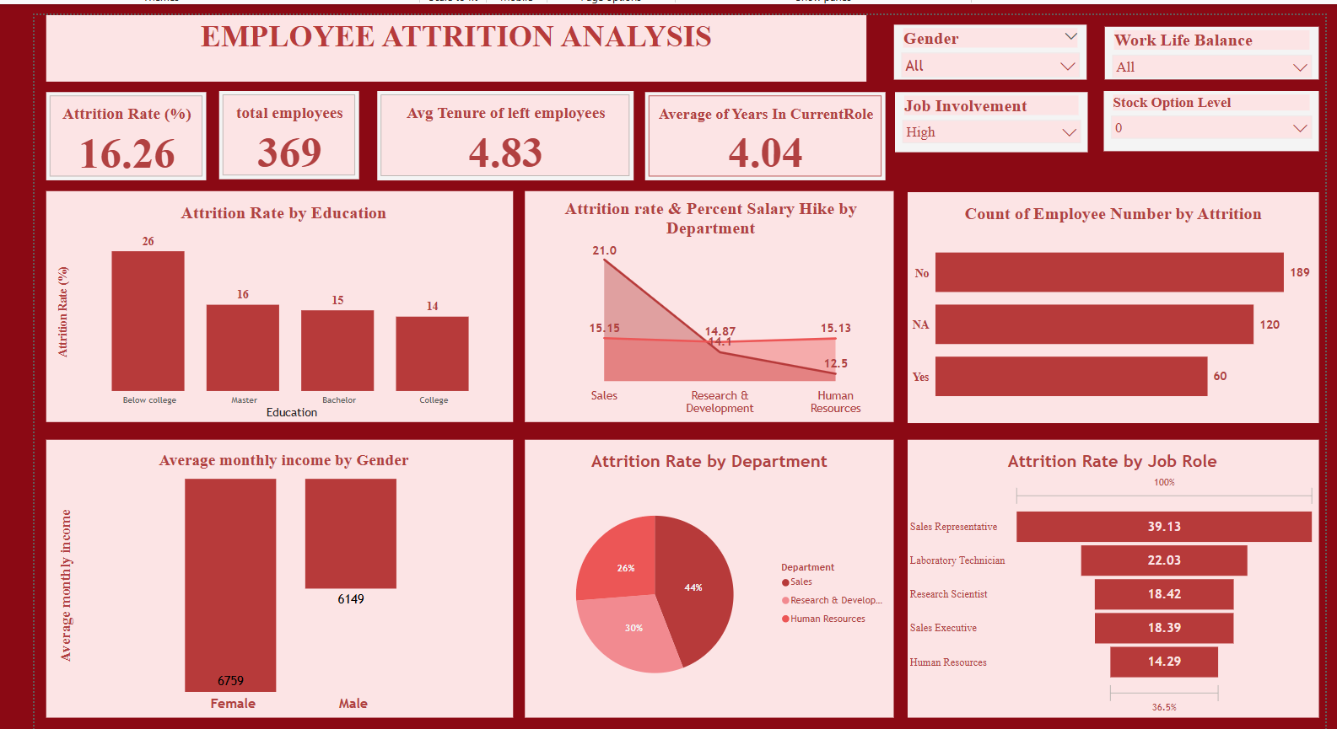

* 1. **Report:**
  2. **Insights:**
  3. 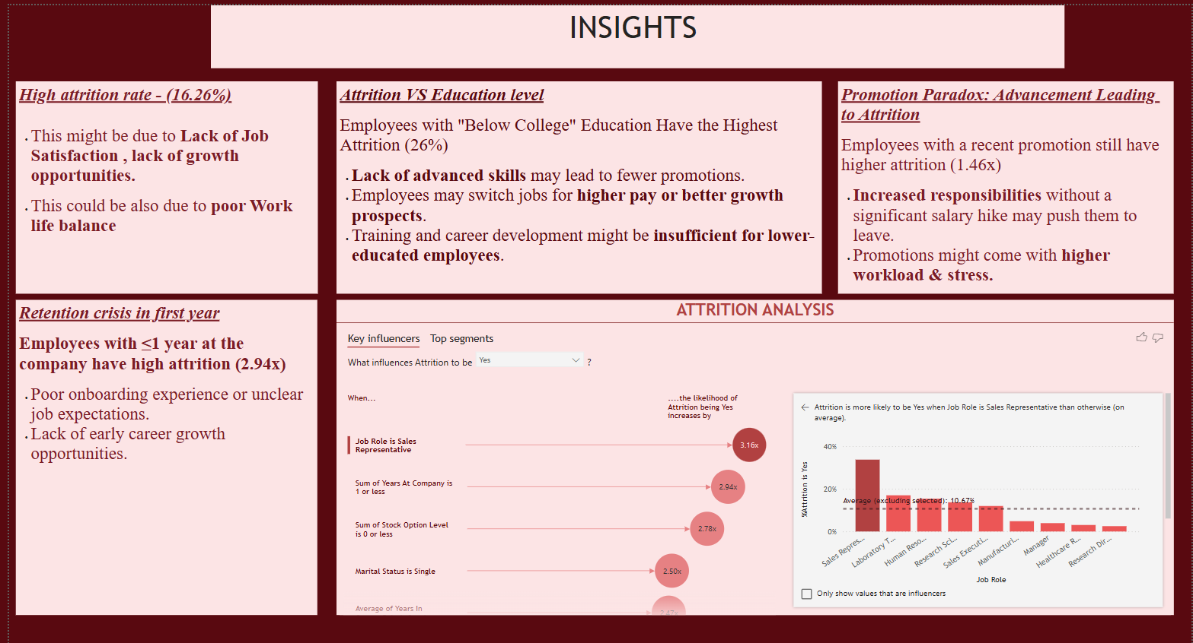
     1. **Recommendation:**

